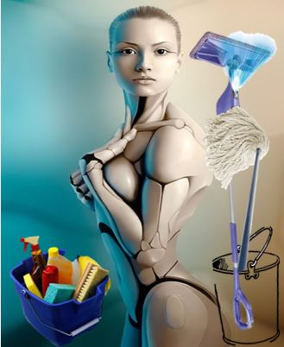
- Long Battery Life
- Flexible in all cleaning areas
- Fast and efficient
- Reliable
- Easily Modified
- Can be customized to your personal desires
- Gender Preferable
- Assorted sizes
- Durable
- Introduces you to a whole new world of CLEANING!
Robo
maid
Sunshyne the
Cleaning Monster®

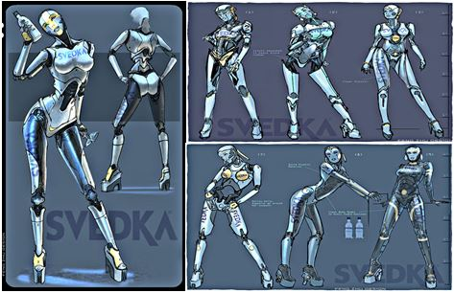
Cleaning has never
been sexier!!!
Yo’gina Town
699 Tokyo Galleria
Nigga Lane , China
25869
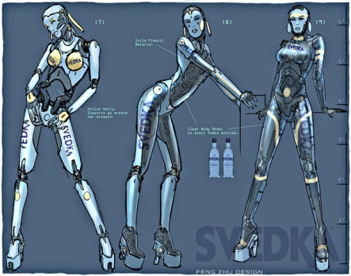
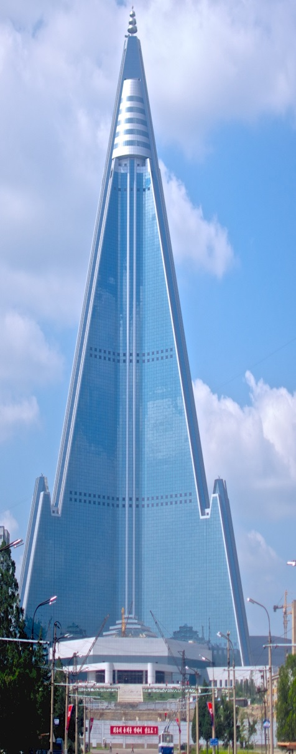
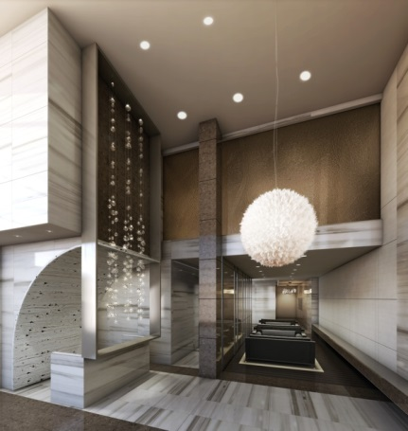
ADDTIONS
Location
Main Office
We would like to introduce our latest model in the line of cleaning products; a machine of artificial intelligence implemented and programmed to give you the easiest and the highest quality of cleaning you’ve ever witnessed, no maid can do what ROBO MAID® does!!!
ROBO MAID
TECHNOLOGY

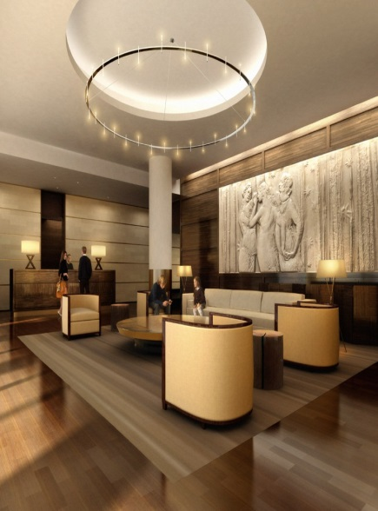
Our maids are an innovative step into the future of traditioal cleaning. We have created a new trend with which everything is more faster and easier.
We have 270 locations in
the United States alone; but
we have 512 global enterprises waiting to be at your service!
Office Area
Lobby
